FSAD WEEK 1 VTU25980:
CREATE TABLE STUDENTS2(student_Name VARCHAR(100),vtu_no VARCHAR(100) PRIMARY KEY,Email_id VARCHAR(100),Department VARCHAR(100));
OUTPUT:
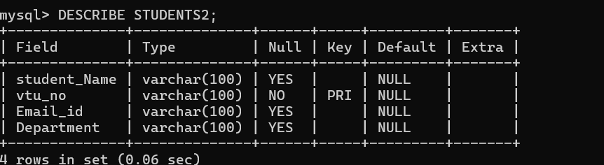
INSERT DATA INTO TABLES:
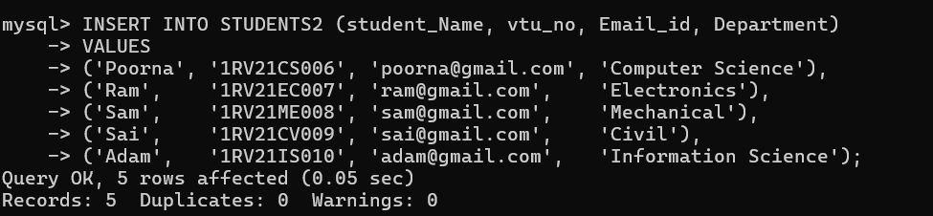
Output:
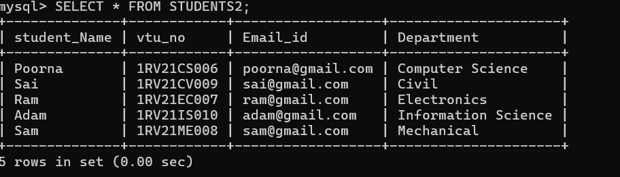

Selecting records using different clauses:
WHERE CLAUSE
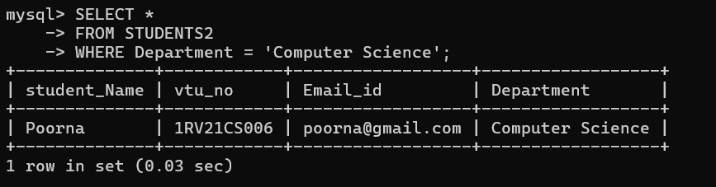

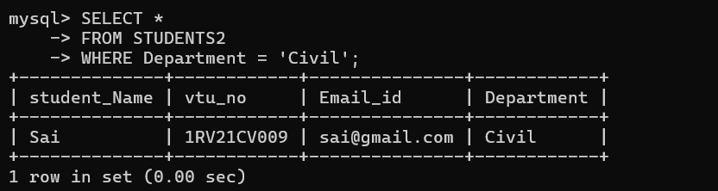
Limit clause
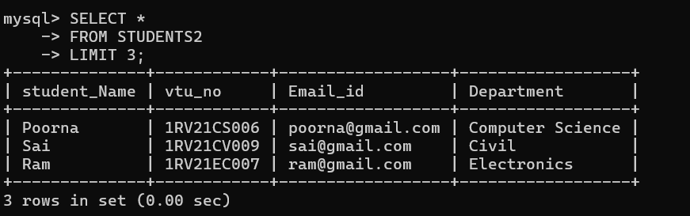
Order by:
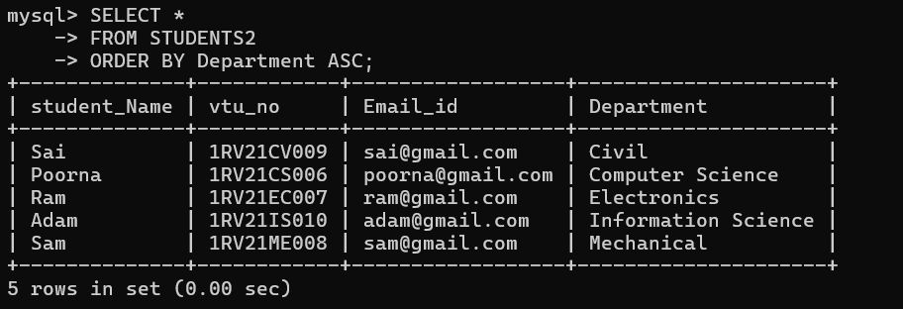
Like clause:
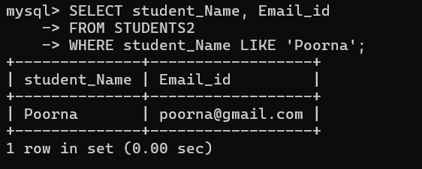

Group by and having:
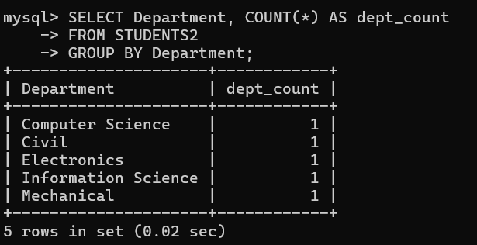
Creating course table and viewing:
